Orosz G. - The Software Engineer's Guidebook

Part I. Developer Career Fundamentals
- Career paths are diverse, and there’s no simple way to define what a “good” career path looks like, as this varies from person to person. The best you can do is figure out which career path is interesting and achievable for you.
- Common types of companies are:
  - Big Tech
  - Medium to large tech companies
  - Scaleups
  - Startups
  - Traditional, non-tech companies with tech divisions
  - Traditional but technology-heavy companies
  - Small, non-venture funded companies
  - Public sector
  - Nonprofits
  - Consultancies, outsourcing companies and developer agencies
  - Academia and research labs
- The two most common are the single-track and the dual-track career paths (compensation rises by level, as do expectations):
  - Single-track career path:
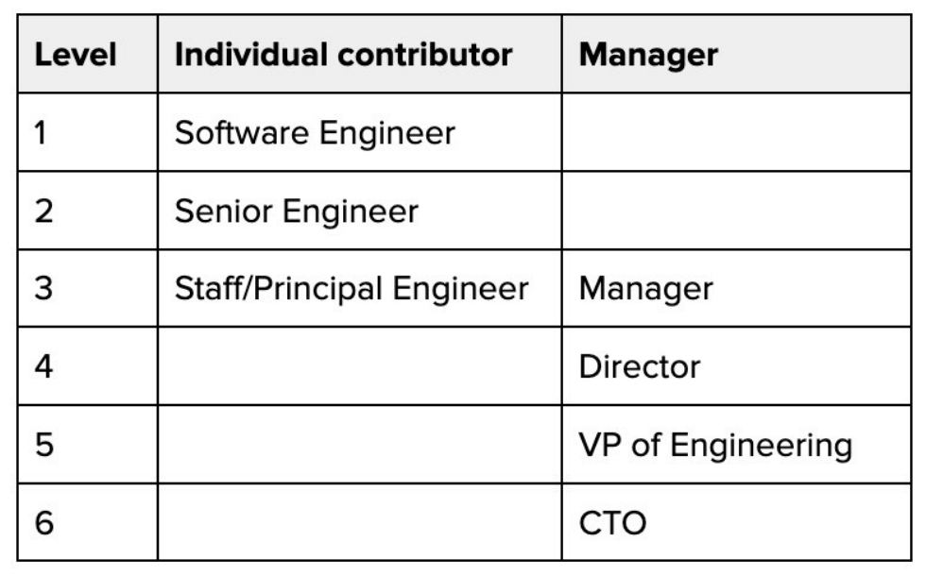
  - Dual-track career path:
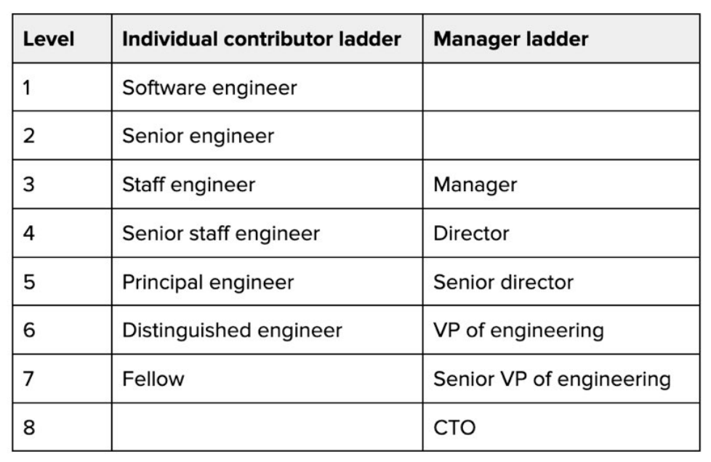
- Companies where engineering grows to above 30-50 people, or which are more forward-thinking, often have a dual-path career ladder, to avoid engineers having to choose between being stuck at a level with similar compensation to a line manager or becoming managers themselves.
- Going back to being an engineer after a manager role, and perhaps repeating in future is more common than you might expect.
- I’ve observed at least a dozen “common” career paths:
- The lifelong software engineer.
- The software engineer turned specialist.
- Generalist/specialist pendulum.
- Software engineer specializing in a niche field.
- Software engineer turned contractor/freelancer.
- Software engineer turned tech lead.
- Software engineer turned engineering manager.
- Software engineer turned founder/business owner.
- Software engineer turned non-software engineer.
- Software engineer/manager pendulum.
- Combination of some of the above.
- A non-linear career path.
- As a hiring manager, I’ve observed what seemed like a trimodal distribution of compensation packages:
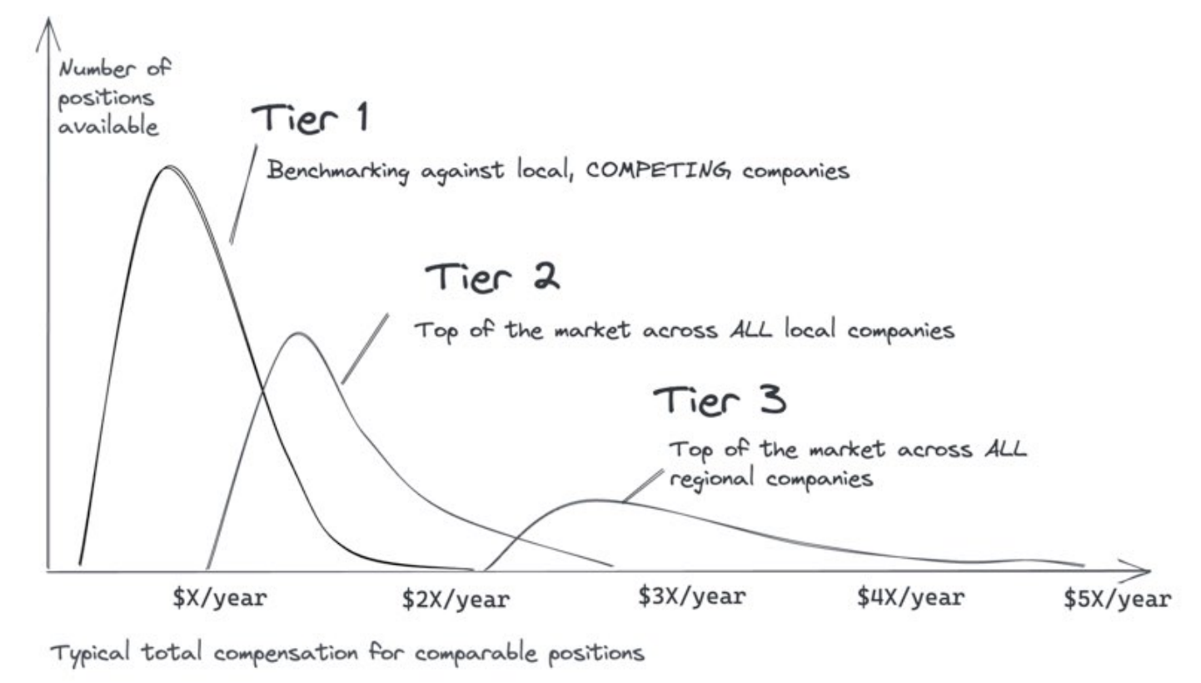
- Total compensation means the combination of three values:
- Base salary
- Cash bonus
- Equity: at publicly traded companies, this is liquid, and at privately owned startups and scaleups it is illiquid.
- Tiers:
  - Tier 1 (local): Companies that benchmark against the local market.
  - Tier 2 (top of local): Companies that aim to pay at the top of the local market to attract and retain standout local talent.
  - Tier 3 (top of regional): Companies that aim to pay the best across the region, and compete with peer tier 3 companies, not local rivals.
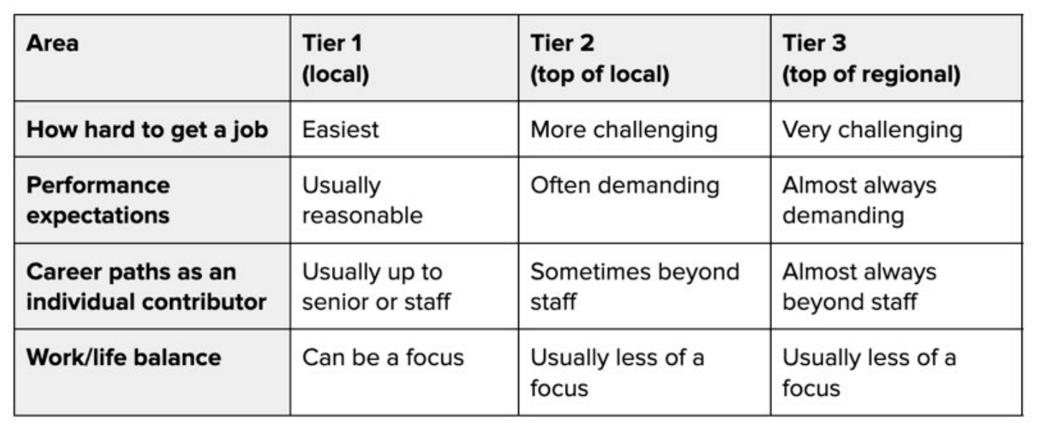
- Plenty of people choose contracting because they don’t want more career progression based on internal company levels, and welcome the opportunity to focus more on their work, and less on performance management processes and office politics.
- A downside for contractors is that their job is often less secure than an equivalent permanent role.
- Great contractors tend to embody many traits we cover in the “Senior” and “Staff” sections of this book.
- A profit center is a team or organization that directly generates revenue for the business.
- A cost center refers to teams or organizations which do not directly generate revenue, but are still needed for the company to operate smoothly.
- What are the implications of working at cost centers or profit centers at larger companies? Here are a few:
  - Promotions: these are almost always easier in profit centers.
  - Performance reviews and bonuses: there’s usually no difference in working at either type of organization between entry-level and up to senior engineering level.
  - Internal transfers: it’s understandable if workers want to be in a profit center. Profit centers are often among the more “boring” teams in an organization, so fewer people want to join.
  - Attrition: cost centers almost always have higher turnover as more employees leave the company.
  - Job security: cost centers are a prime target for job cuts when a company needs to make cost savings.
- Working both in cost centers and profit centers gives you perspective. It’s easy to feel superior to cost centers when you work in a profit center. However, effective companies need both types of teams and organizations, so it’s a useful skill to know how to thrive in each.
- Here are some other factors that contribute to how satisfying your job is:
  - People whom you work with and team dynamics
  - Your manager and your relationship with them
  - Your position within the team and the company
  - Company culture
  - The mission of the company, and what it contributes to society
  - Professional growth opportunities
  - Your mental and physical health in this environment
  - Flexibility. Can you work remote, or from home? If so, how often,
  - and on what notice?
  - Oncall. How demanding and stressful is it?
  - Life beyond work: how easy is it to “leave work at work?”
  - Personal motivations
- The single best career advice for any software engineer is: Own your career!
Why? Because nobody cares about your career as much as you do
- Take ownership of your career path if you want to be successful. Don’t hang around waiting for a manager to step in.
- If you're not seen as someone who “gets stuff done,” then nothing else will matter.
- To do that:
  - Get stuff done!
  - Get plenty of impactful things done
  - Make sure people know you get stuff done
- Record key work each week, including important code changes, code reviews, design documents, discussions and planning, helping out others, postmortems, and anything else which takes time and has an impact. Former Stripe software engineer Julia Evans calls this a “brag document”.
- Keep a “work log”. It helps in several ways:
  - Priorities: you’ll have an easier time knowing your top priorities than colleagues with no such document
  - Feeling good about stopping work at the end of the day. Recording what you do puts the day into perspective
  - Saying “no.”
  - Performance reviews, promotions, and quantifying impact.
- As a software engineer, there are plenty of easy ways to get feedback, and you might already be utilizing some:
  - Code reviews.
  - Ideas and suggestions.
  - Design documents.
  - Peer performance reviews.
- My suggestion is to avoid asking for personal feedback. Instead, ask for feedback about something specific you did, or worked on.
- It’s a fact most people don’t give feedback when it’s not sought. So, you’ll have to seek feedback by asking questions about specific situations.
- Giving feedback contributes to colleagues’ growth, but how do you do this when it’s always easier and more convenient to stay quiet? Here are approaches I’ve consistently seen work well:
  - Call out good work!
  - Be specific.
  - Only give positive feedback when you mean it.
- Giving critical feedback is harder. There are a few ways to minimize the risk of a misunderstanding:
  - Focus your observation on a situation and its impact.
  - Avoid saying “you should do this.”
  - Give negative/constructive feedback in-person.
  - Make it clear from the start you’re on their side.
  - Make it clear it’s just your observation, which they can ignore if they wish.
  - End the discussion positively.
- Here’s how to get something useful out of poorly delivered feedback:
  - Insist on specific examples of what the feedback applies to.
  - Clarify the impact.
  - Ask for suggestions.
  - If you disagree: explain why this is the case.
- Make your manager an ally:
  - Have regular 1:1 time with your manager
  - Tell them, don’t assume they know
  - Understand your manager’s goals
  - Deliver what you agree on, and give updates when you cannot
  - Establish mutual trust with your manager
  - Get your work recognized
- Pace yourself (burnout is a high risk for software developers):
  - Stretching: when you’re learning new things fast and applying them as you go.
  - Executing: this is the ”normal” way of working and involves using your skills and experience to get things done well.
  - Coasting: this means doing less and lower quality work than you’re capable of.
- Mix up stretching, executing, and the occasional period of coasting to optimize for long-term professional growth and avoid burnout, a bit like professional athletes change their pace of work for long-term performance and to avoid injuries.
- If you find yourself coasting for longer than a little while, and the reason is low motivation, ask yourself what needs to change, and then be proactive in making changes.
- There is almost always plenty you can do to achieve better performance review results
- Start early: gather context and set goals
  - Identifying what matters:
    - Ask your manager
    - Ask tenured people on your team
    - Listen to the company’s leaders and executives
    - Ask people with influence
    - Understand how the performance review system works
      - System:
        - Unstructured/ad hoc.
        - Manager-only input and feedback.
        - A peer feedback-based performance review process.
        - A formal, heavyweight process.
      - Details to gather:
        - Who makes the final decision?
        - Who has major input in your performance review?
        - When does the review happen?
        - Advice to ensure a fair performance review.
- The power of habit (or easy ways to ensure a fair performance review, which take little time and effort):
  - Record your wins
  - Keep a work log
  - Share progress with your manager (I suggest erring on the side of oversharing what you do and don’t assume your manager has knowledge of it)
  - Get things done
  - Help others
  - Capture work you do to help others
  - Ask for specific feedback, every now and then
    - Take feedback seriously, but remember that it’s opinion and not a directive.
Just because people give you feedback, doesn’t mean you need to act on it.
Listen to what they have to say, then figure out if it’s valid.
- Before the performance review
  - How much can you rely on your manager as your champion?
  - Find out the important deadlines (for performance review)
    - Fill in any knowledge gaps about your contributions before this
  - Gather feedback from peers
  - Create a self-review
    - Write up a document, listing:
      - The “what.”
      - The “how.”
      - Original goals and outcomes.
      - Examples of competencies.
      - Feedback from peers.
      - Praise and positive feedback.
- The performance review
  - Remember performance reviews are snapshots of a point in time
  - Know the dynamics of the performance review
    - As a rule of thumb, about 20% of people tend to get above-average reviews, 60-70% get average ones, and about 10-15% score below average.
    - I tended to ground myself to expect an average review, and to treat anything better as a welcome bonus.
  - Avoid being too dependent on the outcome
  - Biases are very real
    - Recency bias
    - Strictness bias
    - Leniency bias
    - Horns bias
    - Halo bias
    - Similarity bias
    - Central tendency bias
    - Contrasting bias
  - Be open to negative feedback and don’t dismiss it
    - I suggest pushing back on vague feedback which neglects specifics. Your manager should give feedback that’s specific enough for you to reflect on.
  - Remember, you and your manager are on the same side
  - Play the long game
  - Don’t forget the big picture
  - Know that not all managers are equally capable of giving feedback
- When should someone be promoted?
  - Performing at the next level
  - Impact at the next level
  - Business case for a promotion
  - Opportunity and space for promotion
  - Raise the bar at the next level
- In practice, several more things are required for a promotion to happen
  - Perception
  - Support of others
  - Internal politics
  - Promotion process mechanics
- Types of Promotion Processes
  - An informal promotion process
  - A lightweight promotion process
  - A heavyweight promotion process
  - Hybrid models
- The concept of “terminal level” – sometimes called “career level” – is common at several tech companies. It’s the level software engineers are expected to win promotion to over time, with no expectation of promotion beyond it.
- Engineers who didn’t progress fast enough to these levels would sometimes be exited from the company, or put on performance improvement plans (PIP.) It was a kind of “get promoted or get fired” system.
- The point of defining terminal levels, or career levels, is twofold:
  - Making clear it’s mandatory for engineers to strive to get to this level.
  - Clarifying that there’s no guarantee engineers will get promoted beyond this level.
- Even companies without terminal levels will expect engineers to hit certain career levels.
- Expectations at the terminal level include:
  - Be fully autonomous
  - Unblock yourself
  - Help your team succeed, and support and mentor junior teammates
- Big Tech also takes a different view of promotions and compensation with regard to base salary, bonuses, and equity compensation:
  - Pay for performance is a common approach.
  - Rules for promotion eligibility.
  - A promotion moves compensation to the bottom of the next band.
  - A top-performing employee at a lower level can make more than an average performer at the next level.
  - Promotions are not the only way to reward impact.
- To be promoted, candidates must demonstrate performance at the next level in two dimensions:
  - “What” – impact of the work.
  - “How” – measuring against competencies.
- One of the biggest challenges of senior-and-above promotions at Big Tech is the continuously widening impact radius and complexity of problems.
- The more mature a company becomes, the fewer of these opportunities ([Note] to show impact) there are, and the more complex and time-consuming they are to solve.
- This is exactly why engineers working towards staff promotions often create their own, in-house solution instead of using an existing third-party framework for an organization-wide issue.
- Promotion-driven development is one reason why all of Big Tech has built custom solutions for everything from developer and observability tools, to rebuilding products that didn’t take off.
- What can you do ahead of time to improve your chances?
  - Be realistic.
  - Understand how promotions work.
  - Understand how promotions really work.
  - Self-evaluate.
  - Get feedback from peers.
  - Find a mentor at the next level.
- “Produce, organize, publish” is a good framework for thinking about the buckets of work you do. It’s not enough to do good work, you need to work with others and publish your work so that people are aware of it.
  - Produce work day by day, creating artifacts like code, design docs, postmortems, code reviews, and more.
  - Organize things that help to get things done. This might mean organizing meetings, setting up initiatives, and introducing better ways of working within groups, such as workflow improvements or bug bashes.
  - Publish your work and promote it via 1:1s, presenting at organization or company-wide meetings, knowledge-sharing sessions, other internal or external events, etc.
- In most organizations, as you become more senior, your focus shifts to organizing and publishing, instead of producing.
- Keep track of your achievements. The most practical way to do this is to write down what you do, every week. Summarize key achievements each month and quarter.
- Make an actionable plan. Set goals with your manager to reach that next level, or get closer to promotion. Do this in writing and deliver on them. Keep your manager in the loop about your progress and get feedback. It’s great to do this in a document.
- Don’t get obsessed by promotion because it risks alienating your manager and peers if you’re seen as the person “working only for promotion.” Have a plan, work towards it, and avoid the perception that personal advancement is the only thing you care about.
- Help others so they help you.
- Career paths are not always straightforward, and plenty of successful people endure twists and turns in their careers along the way. It’s helpful to zoom out and look at your career in a bigger context, not just a period of months or a year.
- Don’t let promotions and titles define your self-worth.
- A senior engineer might look at a staff engineer and feel frustrated that they do many things better than their staff-level colleague but are not at staff level, too.
Resist this envy! Getting promoted isn’t based on skill alone; it’s about demonstrating sufficient impact and having the chance to do this when such opportunities are not evenly spread.
- If you need to choose between hitting a professional goal and damaging professional relationships for it, ask if it’s really worth it. Maybe there’s a different way.
- [My note] Compares Engineer A and Engineer B. Interestingly, sometimes staying at “lower” title can help you gain breadth that could help you get even further later on, while climbing the ladder quickly could end up leaving you stuck there and not progressing.
- Happiness shouldn’t be defined by titles and career levels. ([My note] of course: happiness comes from within!)
- Different environments:
  - Product Teams and Product-Minded Engineers
    - Product teams are engineering teams that build a product for external customers.
    - On product teams, engineers who tend to make the most impact are what I call product-minded engineers.
    - They would likely make a good product manager if they ever gave up the joy of engineering.
    - Tips for growing your “product muscle”:
      - Understand how and why your company is successful.
      - Build a strong relationship with your product manager.
      - Engage in user research, customer support, and related activities.
      - Bring feasible product suggestions to the table.
      - Offer product/engineering tradeoffs for projects.
      - Seek regular feedback from your product manager
  - Platform Teams
    - Platform teams are the building blocks that product teams use to ship business-facing functionality.
    - Platform teams tend to be formed when multiple product teams start building solutions for a problem like storage, infrastructure, or for a business capability like payments.
    - Platform teams tend to attract some of the most experienced engineers because they often have an engineering mission to build scalable solutions that developers enjoy using.
    - Thriving in a platform team:
      - Build empathy for customers.
      - Talk to engineers using your platforms.
      - Work side by side with platform customers.
      - Do a rotation working on a product team.
      - Aim for some urgency and focus.
- Basically, companies operate in “wartime” when their existence is at risk, and are in “peacetime” when things are calm and steady.
- 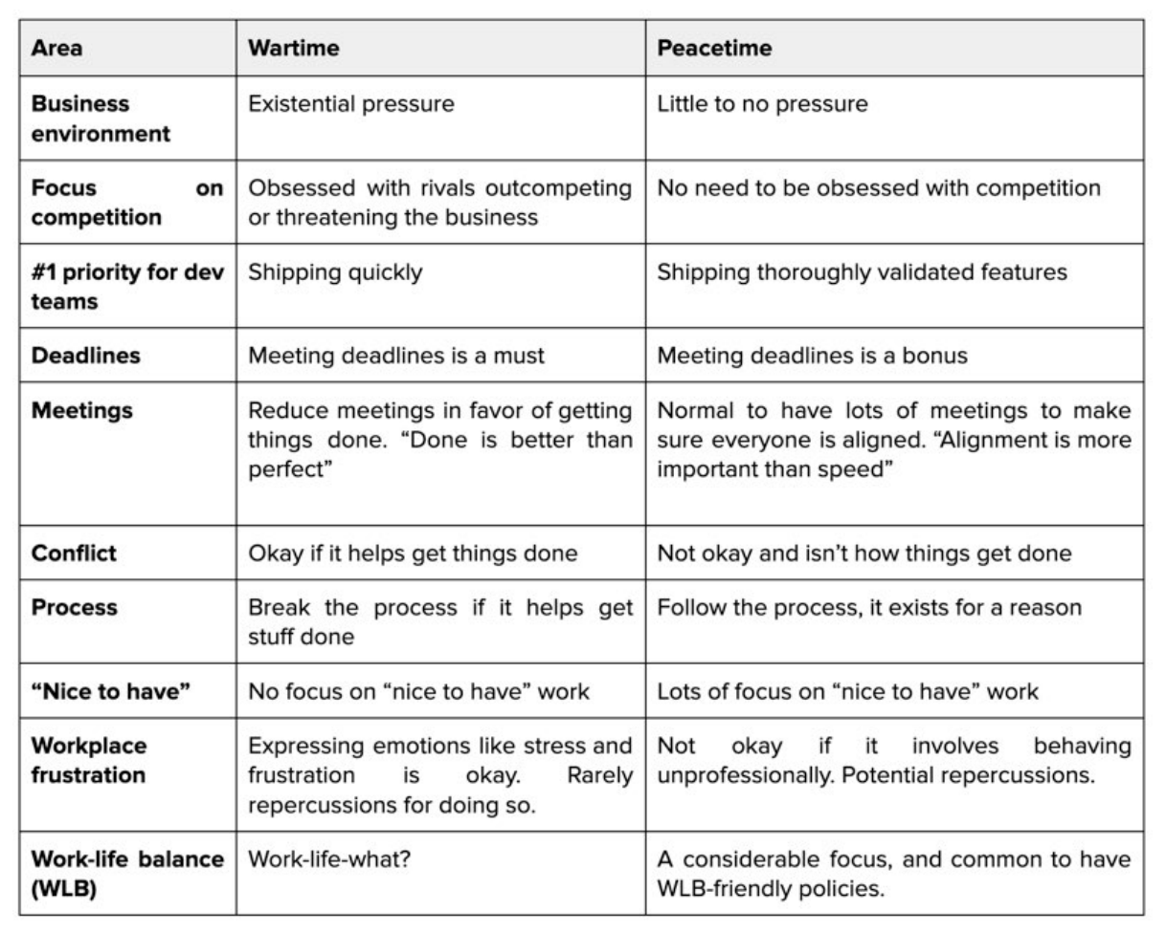
- 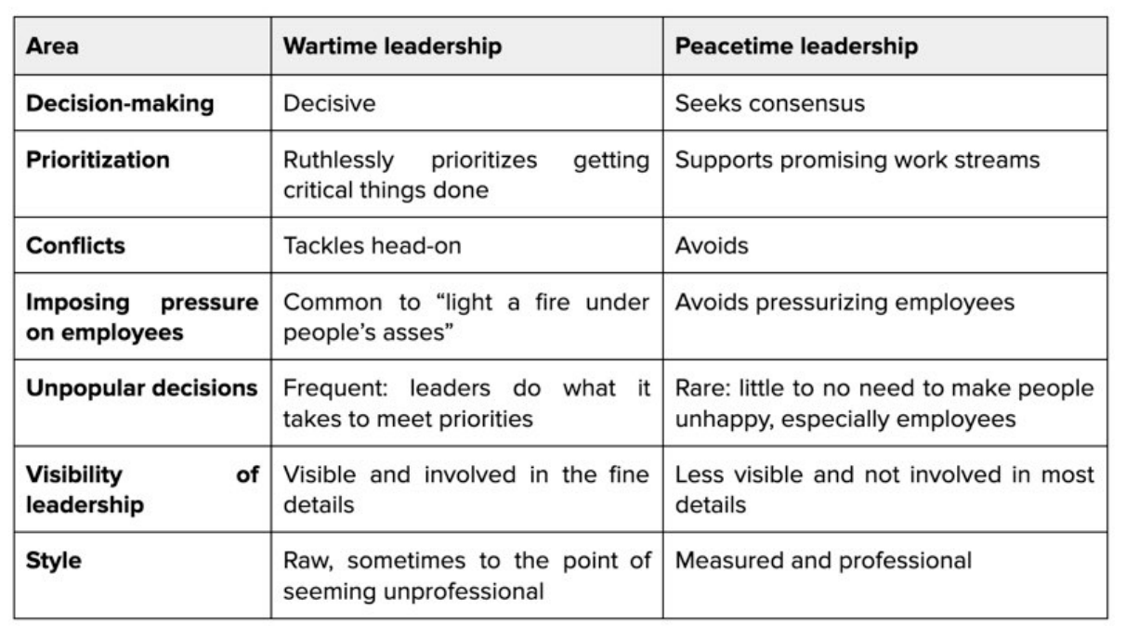
- Thriving in wartime
  - Getting things done: do it quickly with good enough – as opposed to perfect – quality.
  - Handling conflicts: be unafraid of disputes if they help you move faster, but don’t take them personally because they’re usually not personal, but are caused by the wartime context.
  - Allies: don’t worry too much about making allies and just focus on getting the work done.
  - Internal politics: If you have good standing with your manager and skip level, then all’s good.
  - Priorities: Work only on things the business needs, right now.
  - Job stability: Work like your job depends on it – because it might.
  - Pace yourself: Constantly sprinting can end badly, so pace yourself.
  - Burnout: This is a big risk. Pay attention to it, and try to avoid it.
- Thriving in peacetime
  - Getting things done: Get things done with high quality.
  - Handling conflicts: Avoid disputes, even if they’d help you move faster.
  - Allies: Make allies across the teams you work with.
  - Internal politics: Important for career advancement, especially in senior positions.
  - Priorities: Work on longer-term initiatives that benefit the business.
  - Job stability: Job security exists, with time and space to do things well.
  - Pacing yourself: A slow and steady pace can become too slow, so switch up gears sometimes.
  - Stagnating: becoming bored at work in peacetime is a risk – so try to avoid this!
- Most companies shift between wartime and peacetime modes. For a successful venture-funded startup that eventually IPOs, the pattern is generally this:
  - Founding: wartime.
  - Fundraising: wartime.
  - After fundraising: brief peacetime.
  - Between fundraising rounds: the same rhythm as above.
  - A year before an IPO: wartime.
  - After the IPO: it depends.
  - As a public company: more of a pull to operate in peacetime mode at businesses that do well on the market over time.
- The result of a successful wartime focus is that the company gets ahead in the market and creates enough time and space to recoup. This cycle then repeats.
- The sooner you figure out how to be effective in both modes, the better off you’ll be.
- Types of Companies:
  - Big Tech and larger tech companies:
    - Product vs platform: these companies tend to invest most in platform teams.
    - Peacetime vs wartime: these businesses tend to operate in peacetime, as a consequence of enjoying the success which fuelled growth. However, they sometimes switch gears to wartime.
    - Advice for thriving at large tech companies:
      - Keep track of your individual impact.
      - Gain allies and build a network. Personal relationships are rarely unimportant in achieving success at work.
  - Mid or late-stage scaleups
    - Product vs platform: these companies overwhelmingly have product teams. Platform teams are usually in their very early stages – if they exist at all.
    - Peacetime vs wartime: it’s normal for these companies to operate in wartime mode. Talk to people at the company and pay attention to how leadership acts, and you should be able to figure this out quickly.
    - Advice for thriving in high-growth organizations:
      - Tenure is a differentiator.
      - Hiring and onboarding is a focus.
      - Are you in a cost center or a profit center?
      - High growth phases end.
  - Early-stage startups
    - Product vs platform: startups rarely if ever have platform teams. Product teams do the majority of work.
    - Peacetime vs wartime: at most startups it’s wartime. Much depends on the company’s leadership; some founders create less stressful and more balanced working environments. Others don’t.
    - Advice for thriving at early-stage startups:
      - Figure out how you can help the company achieve product-market-fit.
      - Know that startups are risky.
      - Take advantage of the autonomy you have.
      - Tell the founders about your work.
      - Don’t forget the most important thing about working at a startup: get things done!
- Approaches to thrive at any type of company
  - Do standout work.
  - Help others around you.
  - Don’t burn bridges.
- There are plenty of reasons to explore job opportunities, and they fall into a few categories:
  - Actively looking for a job. The most obvious case is when you want or need a new job.
  - Passively open to opportunities. Other times, you’re okay with your current job, but keep an open mind for anything interesting that may come along.
  - When you’re happy in a job. Possible reasons:
    - To establish your market value.
    - To get a sense of how employable you are.
    - To level up via a new job.
- Waiting on a Promotion vs Switching Jobs
  - Promotions are typically backward-looking. To get promoted, you are expected to perform at the next level for 6-12 months, and a promotion confirms you did.
  - The more senior you are, the riskier a new job is.
  - Tenure becomes increasingly important as you get more senior.
  - Before quitting, consider what you’d leave on the table.
  - The more senior you are, the harder it is to get promoted.
  - Don’t forget that missing out during a promotion cycle might feel like a big deal, but you probably won’t remember it a decade later. Play the long game and think about your strategy across that timeframe.
- Preparing for Tech Interviews
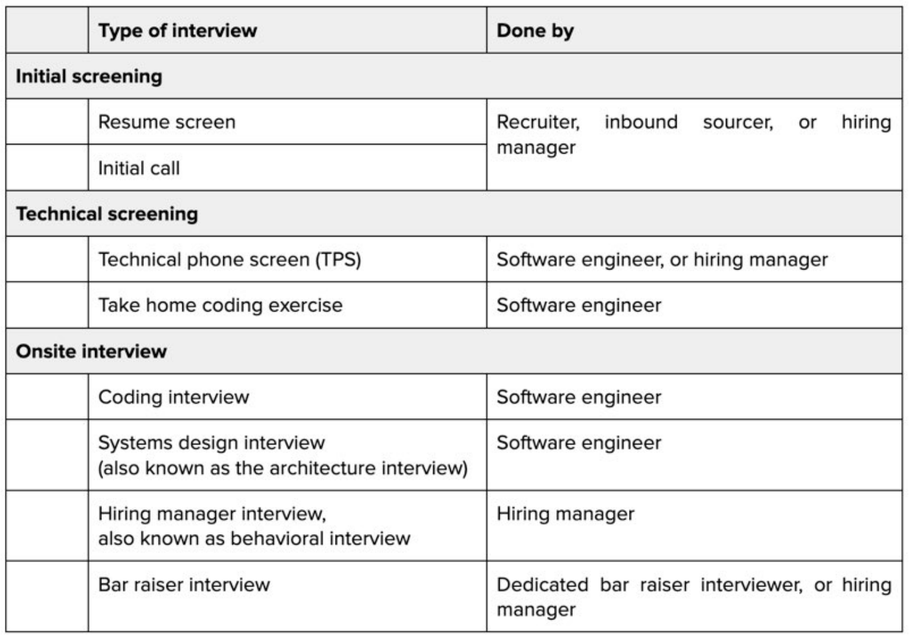
- Stages:
  - Initial screening
    - Parameters:
      - Has the basic qualifications for the role.
      - Has the required soft skills.
      - Is motivated for the interview process.
    - Phases
      - The resume screen
        - Few suggestions for writing an efficient resume
          - The goal is to convince the person doing the screening that it’s worth doing an initial call with you. The goal is not to describe your career in minute detail.
          - Tell the story you want the recruiter or hiring manager to hear for the position you’re applying to. Highlight relevant experience.
          - Tailor your resume. Consider having a “master” version and tweaking it each time.
          - Use an easy-to-scan template (e.g. The Pragmatic Engineer’s Resume Template)
          - Stand out in results, impact, and numbers. Define the impact of your work, ideally with numbers.
          - A positive referral usually helps more than a fantastic resume. Seek out referrals from your network.
      - Initial call with a recruiter or hiring manager
  - Technical screening
    - There are several popular ways to conduct this round:
      - A synchronous coding challenge.
      - A take-home coding challenge.
      - Another format to probe technical skills.
    - How to prepare for the technical screening:
      - Gather information on what to expect.
      - Understand how the challenge is evaluated.
      - For synchronous exercises, ask questions from the interviewer.
      - For asynchronous tasks, set expectations for completion.
      - Find out if detailed feedback is provided before you invest time.
  - Onsite interviews
    - The name refers to the common practice of holding the final set of interviews at the employer’s offices. These are typically split into the following categories:
      - Coding interview
        - “Cracking the Coding Interview” by Gayle Laakmann McDowell
        - “De-Coding the Technical Interview Process” by Emma Bostian
      - System design interview: also known as the “architecture interview.”
        - “System Design Interview – An Insider’s Guide” by Alex Xu
        - “System Design Interview – Volume 2” by Alex Xu
      - Domain deepdive
      - The hiring manager interview
      - The bar raiser interview
      - Other interview types
        - Smaller companies often have a session where candidates meet their potential future teammates and take questions from them. At some places, engineers meet their potential product manager (PM) or other business stakeholders, who also interview them. All these interviews are hard to prepare for upfront.
- Down-Leveling
  - The seniority roller coaster:
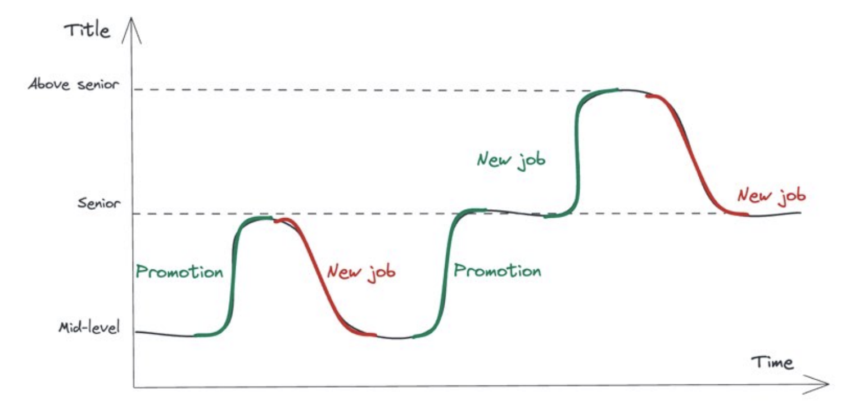
  - There can be several reasons for dropping in title while gaining in compensation, such as:
    - Moving up a “tier.” (company tier)
    - Titles across companies have different expectations and compensation.
    - Interview performance.
      - The most common reason for down-leveling
    - Changing companies and technology stacks might lead to a lowerlevel offer.
  - Dealing with down-leveling
    - Know that down-leveling is common when moving up a tier.
    - Do your research on what the “lower” title means.
    - Tell the hiring manager if you disagree with the leveling.
    - Consider rejecting an offer if you disagree with its leveling.
- Up-Leveling
  - To get an up-level offer, several things need to be present:
    - Perform well at the interview.
    - Possess leverage to get a higher level.
    - Have some people inside the company “fight” for you, internally.
  - After you secure a higher level, be aware that expectations will be raised from day one. Be sure to clarify these and work hard to live up to them as you progress in your elevated role.
- Onboarding to a New Job
  - Perceptions of you are shaped during your first few months in a new workplace, and often last years.
  - At all companies and levels:
    - Consider catching up with your future manager before you start.
    - Read the book “The First 90 Days” by Michael D Watkins.
    - Keep a work log/brag document from the start.
    - Keep a weekly journal.
    - Clarify your goals with your manager for the first month, the next 3 months, and the first 6 months.
  - Onboarding to a smaller company
    - Clarify the work you’ll do before you join.
    - Connect with the most senior person, early on.
    - Don’t assume how things work; ask.
    - Aim to ship something in week one. There’s no excuse not to at a small company.
  - Onboarding to a larger company
    - Get an “onboarding buddy,” even if not assigned one.
    - Keep a “cheat sheet” document in which you record everything that’s new. This could be acronyms and their meanings, build commands, bookmarks to key resources, and much more.
    - Familiarize yourself with the company’s tech stack.
    - Accept that many things don’t make sense at first, especially if you arrive from a smaller company. Don’t worry, this is normal!
  - Onboarding to a senior-or-above role
    - Connect with a senior-or-above peer. Understand how they organize and measure their work.
    - Prioritize being productive on the team’s codebase, and becoming hands-on with it.
    - Clarify 3, 6, and 12-month expectations with your manager.
    - Understand current and future projects and the team’s priorities.
    - Find and browse outage documents like postmortems which are relevant to your team and area.
    - Start writing a list of engineering teams worth knowing.
  - Onboarding to a staff-or-above role
    - Meet your team early and make a friendly impression.
    - Also meet peer staff+ engineers early.
    - Staff+ roles differ by company, so figure out what’s expected and what’s not in your role.
    - Clarify 3, 6, and 12-month expectations with your manager, and also ideally with your skip-level manager (the manager of your manager). What are the team’s top priorities and the biggest problems to address?
    - Spend time with product folks to understand their current concerns and plans.
- If you have the good fortune to start on the long-term career conveyor belt, do your best to avoid tripping, and ride it to success, home ownership, and eventually retirement.
- No one cares about your career as much as you do. Not your managers, and not your coworkers. So figure out how much you care about career progression and put the appropriate amount of work into it.

Part II. The Competent Software Developer
- Almost all companies expect software developers to progress to the senior level.
- 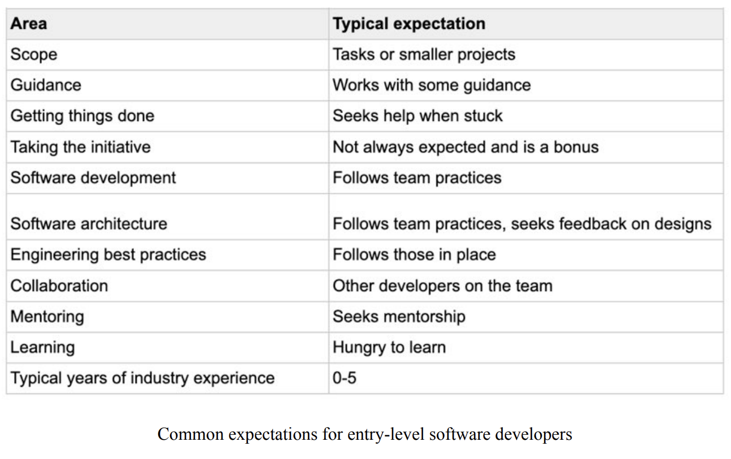
- I always knew which engineers on my team “got things done,” and did so reliably. These colleagues were good at breaking down work, realistic in their estimates, autonomous in unblocking themselves, and delivered quality work.
- Building a reputation for getting things done is helpful in several ways. You will be given more impactful and challenging projects, which will accelerate your learning. You will almost always get more autonomy, as your manager views you as reliable and not in need of “hand-holding.” And your career will likely progress faster
- Several approaches to growing as a reliable developer:
- Focus on the most important piece of work
  - Ask what is the most important work. Your answer is your #1 priority. Make sure you definitely, absolutely deliver that piece of work within the agreed timeframe.
  - Make a habit of always completing your #1 priority.
  - Learn to say “no”.
    - The sooner you learn to say “no,” the more helpful this skill will be – and it truly is a skill.
    - The easiest way to turn down a request is to reply, “yes, I’d like to help, BUT...”

- Unblock yourself
  - Building software is complex and often has unforeseen obstacles.
  - Software engineers perceived as reliable are able to solve blockers faster than colleagues. How do they do it?
    - Know when you’re blocked
      - If you go more than 30 minutes without meaningful progress – or an hour at most – then admit you’re blocked
    - Try different unblocking approaches
      - Do rubber-ducking.
      - Draw it on paper.
      - Read documentation and references.
      - Search online for similar problems.
      - Post a question on a programming Q&A site.
      - Use an AI tool.
      - Take a break.
      - Start from scratch, or undo all changes.
    - Get support to unblock yourself
      - Some blockers are due to a lack of knowledge from not having seen a problem before, while other blocks stem from a lack of access to the right people.
      - The easiest way to start to get unblocked is to tell your team: “hey, I’m stuck on this problem. Can anyone lend a hand, perhaps pair with me on it?”
      - Sometimes, you’ll be blocked by waiting on somebody.
      - The bigger your workplace is, the more common it is to be blocked by waiting on someone else.
    - Learn how to escalate without ruffling feathers
      - What is escalation in this context? It means asking your manager or somebody higher in the chain of command, to communicate your message using the authority of their position.
      - It can also involve reaching out to someone with authority elsewhere, for example, the manager of the person being unresponsive to your requests.
      - Escalation can speed things up, but it also has the potential to harm relationships if used carelessly.
      - Aim to not harm personal relationships when you escalate.
      - An engineer who likes working with you is more likely to help in the future if they don’t see you as aggressive.
      - My approach to escalating is this:
        - Explain.
        - Ask. If nothing happens, ask why.
        - Warn.
        - Escalate.
      - Aim to make an escalation a win-win outcome.
      - And when the other person does what you requested, be sure to thank them and let people involved know that they helped.
    - “Help! I’m blocked!” – a cheatsheet
Below are common situations that indicate you are blocked, and some approaches for handling them:
      - Planning
        - Not enough clarity on what to do (“missing information” blocker.):
Make clear what information is missing and escalate to colleagues who can help.
        - Not knowing who to consult for information about a certain area (“missing information” blocker.):
Ask for help from your lead or manager in identifying these people, then make a list of points of contact. Consider sharing it with your team.
      - Building
        - New language or framework (“missing information” blocker, again.):
If it’s a language or framework, ask for
recommended learning resources. If it’s an internal framework, find the documentation, source code, and the colleagues who created it. Start small by learning just enough to solve your problem, before diving deeper in.
        - Error messages that make no sense and googling doesn’t help (“missing information” blocker.):
Consider pairing with a teammate after trying to solve it yourself. If the error message is related to an internal component, reach out to the team who built it.
        - Puzzled about how something works (“missing information” blocker.):
Try decomposing it by drawing it, looking at the source code, and doing some research. If you don’t make progress, ask for help.
        - Build problems (“missing information” or “waiting on others” blockers.):
Contact the person or team who set up the build and ask for pointers on debugging the issue.
        - Missing dependency on another team/service that arises midway through a task (“waiting on others” blocker.):
There’s not much you can do, beyond letting the other party know they’re a blocker, escalate, and pause this workstream – or try to do a workaround. It’s a good idea to involve your manager, or at least inform them.
        - Access problems (“waiting on others” or “missing information” blocker.):
Your manager is your best contact, as access rights almost always go through them. Explain the problem and why you need access.
        - Misleading documentation (“missing information” blocker.):
A framework or system doesn’t behave as documented.
Contact the team owning the documentation and offer to fix it. If you can modify the documentation and make the changes, while letting the documentation owner know, then do so. If you need help to progress, the documentation owner is a good source of guidance.
        - Outages, or systems being down, which prevent you from working or validating that what you built is working (“waiting on others” blocker.):
Flag the outage and escalate it; there’s a chance you’re the first person to notice it. Once you get acknowledgement, there’s not much to do but wait and work on other things.
      - Testing
        - Tests fail non-deterministically (“missing information blocker.)
These are tricky and require debugging to understand what’s happening and why. Try pairing with a team member or ask in the chat if anyone’s had similar issues.
        - Missing test data, such as data to reproduce a test case, or production-like data (“missing information” blocker.)
Figure out how to get this data.
        - Tests are too slow (“waiting on the machine” blocker).
A good opportunity to step up and look for ways to make tests faster.
      - Reviewing
        - Waiting on code review (“waiting on others” blocker)
Ping reviewers to ask for reviews directly, and escalate if you don’t hear back in a reasonable time.
        - Merge conflicts: these are time-consuming, and there’s no avoiding them. Keep pull requests small to make merge conflicts less problematic
      - Deploying
        - Permissions/access problems (“waiting on others” blocker)
Find colleagues who can give access, and escalate if needed.
        - Deployment is too slow (“waiting on the machine” blocker).
Consider getting your hands dirty or contact team that owns deployment tooling.
      - Operating systems and maintenance
        - Bugs which can’t be reproduced (“waiting on others” blocker.)
More information must be sought, you’ll very likely be waiting on a response, with no way to escalate.
        - Not enough logs to debug system issues (“missing information” blocker.)
Add more logs, monitoring, or alerts, and deploy these, then try again to debug the production issue.
        - Outages (“missing information” or “waiting on others” blocker.)
Alert your manager and team, and if possible, jump in to mitigate the outage. After the issue is resolved, there will likely be an investigation into the root cause, and a postmortem.
- Break down the work
  - Think about stories, tasks, and subtasks
  - Prioritize work which gets you closer to shipping something
  - Don’t be afraid to add, remove and change tasks
    - Remember, the goal is to build software that solves customers’ problems, not to close tasks.
    - Tasks are just a tool for organizing work; don’t forget this.
- Estimate the duration of work
Estimation is a learnable skill. However, its challenges differ by the type of work at hand.
  - Estimating work similar to what you did previously
  - Estimating work you’ve not done before. Seven common categories of work:
    - Similar work to that of a colleague.
    - Refactoring.
    - Greenfield work using a technology you know well.
    - Integrating with a system you don’t know well, using a well-known technology.
      - You can always give an “ideal estimate,” which assumes no issues with the system. Also provide a “worst-case” estimate which assumes the system will behave strangely and that workarounds will be needed.
    - Building something simple with a mature technology you don’t know well.
    - Building something simple with a new technology you don’t know well.
      - Build a proof-of-concept with the new tech, and don’t make an estimate until you’re confident using it.
    - Building something complex and integrating with a system you don’t know well, using an unfamiliar new technology.
- Seek out mentors
  - Mentors are experienced engineers whom you can turn to in confidence with questions and doubts.
  - Some companies have formal mentorship programs, but at most places you need to find mentors by yourself – and it won’t be a “formal” relationship.
  - The tech tribe of mentors
    - The dedicated mentor
    - The ad hoc mentor
    - The internet mentor
- Keep your “goodwill balance” topped up
Before you reach out to colleagues, keep in mind the potential implications for goodwill between yourself and others.
  - Everyone has a goodwill balance
    - When you help others, your goodwill balance increases. When you ask for favors, it can go down. And when you interrupt people for no good reason, it definitely reduces.
    - The more junior or new on a team you are, the higher your goodwill balance is. People are willing to help; in fact, they expect to. But this balance will quickly drain if you don’t take time to solve things yourself, ask too many trivial questions, or frequently interrupt others.
    - Avoid using up your goodwill balance too quickly.
    - Go prepared when asking a colleague for help. Explain the problem clearly, summarize what you’ve tried so far, and what your next step would be if they cannot help. If they’re busy, respect their time as they probably have other priorities. In this case, ask them for a quick pointer.
    - Of course, this all applies after you onboard your team. During onboarding, you have a large goodwill balance.
  - Regularly top up your goodwill balance
    - How do you build up your goodwill balance? By doing the opposite of activities that decrease it:
      - Make yourself available to others. Sit with them and help solve their problems.
      - Share your expertise to make others’ work easier.
      - When someone helps you, and it solves your problem, thank them – perhaps even publicly in a team setting.
  - Avoid working alone, when possible
    - Assign them a “project buddy.”
    - Ask an engineer on your team to be your buddy for a project, by doing a quick check-in with you each day, reviewing your planning, and doing code reviews.
- Take the initiative
  - Some of the most productive engineers I have seen consistently pick up smaller or larger pieces of work which were not asked of them. This is called taking the initiative.
  - Engineers who are perceived as reliable and productive go above and beyond the call of duty.
  - The more autonomous the culture you work in is, the more important this trait becomes.
  - Approaches to taking the initiative (possible ways)
    - Document unclear things.
    - Volunteer for investigations.
    - Investigate interesting tools or frameworks your team could use.
    - Talk with your manager about upcoming projects.
  - As a word of warning: ensure you get your “expected” work done before taking on many new initiatives. New initiatives help others see you as a productive person, assuming you get your most important and assigned work done, first. If you must choose between doing something new or finishing your current work, I advise you to finish what’s needed.
- As a software developer, you will likely spend around 50% of your time at work coding – potentially even more!
- Practice Coding: a Lot!
  - Code regularly
    - Developing your coding skills is a bit like sports training. You can read all the resources available on how to code well, and which techniques will make you faster, stronger, and better. But the biggest contributor to your progress is always how much you practice.
  - Ask for code reviews
    - Most tech organizations do code reviews; in fact, you cannot push code to production at many places without first going through a code review.
    - Aim to get feedback on all the code you write, even if code reviews aren’t required.
    - Artificial Intelligence (AI) tools are also useful sources of coding feedback. But be aware that not all AI-generated feedback is always accurate. AI tools are better than nothing, but nothing beats a thorough peer review.
    - Learn from code reviews. Consider making notes on the feedback you get.
    - How do you deal with code reviews that feel harsh?
      - Read Angie’s 10 commandments.
  - Read as much code as you write
    - If you only focus on writing code, you might develop styles and conventions nobody uses. And later, it may be hard to understand other people’s code.
    - It’s beneficial to read code written outside of your team or company.
  - Code some more
    - Build a side project.
    - Complete a tutorial/training with coding exercises.
    - Do coding challenges.
    - Do regular code katas.
- Readable Code
  - Readability is one of the most important characteristics of all code. It’s equally important as code that’s correct and does what’s expected.
  - However, it is harder to verify that code is readable than to verify that code is correct. This is because the correctness of code can be established by using tests: there’s a binary “yes, it is correct,” or “no, it’s incorrect,” answer. There is no equivalent approach to pinpointing hard-to-read code.
  - The biggest risk of unreadable code is that it starts a low-readability spiral. An engineer making a change spends much time figuring out how the code should work. Instead of making the code more readable, they may make the smallest possible change, resulting in even less readable code. The next person will then spend more time understanding the code and might break the system, or just give up, delete the code, and reinvent the wheel.
  - There are two important judges of how readable code is: yourself and everyone else who reads it.
    - Readable code begins with code you find easy to read.
    - The test of readable code is simple: can others understand it?
  - Coding is a social activity. Your code doesn’t exist in a vacuum, implementing a lone task. The code you write will be re-read by many other developers to understand or modify how it works.
  - Things to pay attention to:
    - Naming
    - Well-structured
    - Keep the code simple (KISS)
    - Single responsibility
    - The “DRY” principle
    - Comments
      - Explain the “why” on the code, not the “how” in your comments.
    - Continuously refactor to maintain readability
  - Book suggestion:
    - “Tidy First?” by Kent Beck
    - “The Art of Readable Code” by Dustin Boswell and Trevor Foucher
- Writing Quality Code
  - Use the right level of abstractions
    - Book suggestion:
      - “A Philosophy of Software Design”
    - Building a system with the “right” level of abstraction is something you improve at, the more you do it. After all, you don’t want to break up a system into too many small pieces, as excessive numbers of tiny classes add unnecessary cognitive load.
  - Handle errors, and handle them well
    - Have a consistent error-handling strategy.
    - When in doubt, use defensive programming.
      - Validate inputs, especially from users.
      - Expect invalid responses.
      - Expect malicious inputs.
      - Expect exceptions and errors.
  - Be wary of “unknown” states
    - Allowlists: create a list of successful responses (the allowlist) and assume everything else is a failure.
    - Blocklists: create a list of responses considered failures (the block list) and assume everything else is a success
    - Handling an “unknown” state can cause unexpected problems.
- Become Proficient in a Language
  - Learn the fundamentals of a language
    - A good way to go through the basics of a language is to consult its documentation
  - Go a level deeper
  - Learn the “main” framework you use with a language
  - Learn a second language
    - It’s easier to compare strengths and weaknesses.
    - Go deeper into your first language.
    - Shake the habit of only using your “main” language.
    - It’s easier to learn more languages.
  - To go broad or go deep?
    - I advise developers to “go deep” in at least one area, early in their careers.
- Debugging
  - Know your debugging tools
    - Start by discovering the debugging tools which come with the IDE you use.
  - Observe how experienced developers debug
  - Learn how to debug without tools
    - Log to the console.
    - Paper debugging.
    - Write (unit) tests.
- Refactoring
  - Practice refactoring as often as possible. Getting good at refactoring is similar to learning to code. You can read all you like about a topic, but without doing it you’ll never truly master it.
    - Start by refactoring your own code after it’s written.
    - Get ideas for refactoring via code reviews – and act on them.
    - Read through the code.
    - Write up a list of things you’d like to refactor.
  - Know your IDE’s refactor functionality – and use it
  - Refactor the tests
  - Make refactoring an everyday habit
- Testing
  - Test code before requesting a code review or committing it.
  - Reliable developers care deeply about edge cases.
    - Bugs that emerge will almost certainly be overlooked edge cases.
  - Automated testing is a tool commonly used by competent developers.
- Tools of the Productive Developer
  - In software, tools training is rare.
  - Some companies are better than others at educating professionals on how their tooling, build, deployment, and other systems work. But often, you have to figure these things out yourself.
- Your Local Development Environment
  - Your interactive development environment (IDE,) or coding text editor. Get familiar with it and learn its capabilities!.
  - Some capabilities you should find in a modern IDE:
    - Refactoring
    - Compiling
    - Running the project
    - Hot reload
    - Debugging
    - Advanced debugging
    - Running tests
    - Debugging tests
    - Creating a pull request
  - Understanding how to use your IDE effectively will shorten coding iteration cycles and speed up your work.
  - With modern tools and decent hardware, there’s little reason to wait more than a second or two to view changes, be they code refreshing in a web browser, unit tests running on the backend, or changes showing up in the mobile simulator.
  - Don’t accept a slow cycle from an edit to the change being live in your environment.
  - Configure your IDE and workflow:
    - Set up shortcuts for frequent actions
    - Configure your color scheme
    - Set up code formatting and linting, if needed
  - If your team already has code formatting and linting rules in place, ensure these settings are applied to your local development environment.
  - If your IDE has a playground, use it.
- Frequently Used Tools
  - Git
    - The main thing is that you can create pull requests and deal with conflicts, which are the most common actions.
  - The command-line/terminal
    - Familiarize yourself with common command-line commands like navigating directories, listing directory contents, running scripts, searching within the contents of files, or setting the value of environment variables.
    - The best way to become familiar with the command line is to start using it for tasks.
  - Regular expressions
  - SQL
    - So learn the basics of SQL: how to create a table, how to use the SELECT command with the FROM, WHERE, ORDER BY, GROUP BY, HAVING clauses, and also some more advanced aspects like joining tables, or using views.
  - AI coding assistants
    - Inline coding assistants.
    - Generative AI chat interfaces.
  - Development tools at your company
    - What are the internal – possibly custom – development tools that engineers in your workplace regularly use?
  - Your “productivity cheat sheet”
    - I kept a document of useful links to internal tools and dashboards, and a list of commands, prompts, and queries. This document was useful for years!
    - Consider creating a personal “productivity cheat sheet.” Start with a blank document, and add the names of tools with short descriptions of what they do, links, commands, and other notes. This small document can help a lot, especially during the first few months on a new team.
- Ways to Iterate Quickly
  - Read existing code and understand what it does
    - Ask someone to walk you through the structure.
    - Draw out classes/modules, and how they connect.
    - Share your code map with teammates.
    - Create a cheat sheet.
  - Know how to debug the CI/CD
    - CI stands for “continuous integration,” and CD for “continuous deployment.” Having a CI/CD system in place is commonplace at most tech companies and startups.
  - Know how to access production logs and dashboards
    - Production logs, dashboards and metrics
    - How to filter those logs to certain users
    - How to query various relevant data sources for debugging
    - How to access crash dumps, errors, and exceptions for specific users
    - Processes to follow when debugging production logs. For example, if you access personal information when debugging production data, there may be a data protection process to follow. Ask your manager and more experienced engineers.
  - Make small code changes when possible
    - Break your changes into one small PR each, with each PR changing one thing only.
    - Summarize the “why” and the “what.”
    - Mention edge cases covered and those not covered.
    - Be clear what’s not in scope for a change, especially if there is expected to be follow-up work in future PRs.
  - Write and run automated tests
    - The most time-consuming thing about writing code tends to be precisely that: writing the code.
    - The next most time-consuming activity is fixing the things your newly written code broke!
    - Run automated tests already in place in the codebase and write new automated tests which exercise your code and can catch future regressions:
      - Unit tests
      - Integration, screenshot, and end-to-end tests
  - Don’t just wait for code reviews: ask for them
    - When you have code reads, would they mind if you ping them about this? Is there a team channel where people announce reviews?
  - Get frequent feedback
    - The two fastest ways to grow into a reliable software engineer:
- Build things: solve problems by writing code and ship that code to production.
- Get feedback: does your solution work as expected? Does it do what you intended with no side effects?
    - Get feedback by shipping to production.
    - Ask for feedback on your work
      - The best time to seek feedback is when you finish a task or wrap up a project.
    - Don’t take it personally If you get feedback that sounds judgmental, or isn’t helpful. Instead, probe more to translate this into something more actionable.
  - Compare your output with teammates’ outputs.
    - The goal is simply to get an idea of how you’re doing compared to the team’s normal pace of work.

Part III. The Well-Rounded Senior Engineer
- From this chapter onward, we discuss “software engineering” and not “software development.” For this reason, the title “software engineer” replaces “software developer.”
- In my personal usage, software development is a subset of software engineering.
- Software development refers to the process of building software, such as:
  - Outlining a basic plan
  - Coding
  - Testing
  - Deploying
  - Debugging
- Software engineering is a lot broader than only development. It also involves:
  - Gathering requirements
  - Planning a solution and analyzing tradeoffs between approaches
  - Building the software
  - Shipping to production
  - Maintaining the solution
  - Extending the solution to new use cases
  - Migrating to other solutions
- A software engineer should be invested in the long-term impact of their work, as well as the short-term.
- Software engineering is software development (or programming) over a much longer time frame: “We propose that ‘software engineering’ encompasses not just the act of writing code, but all of the tools and processes an organization uses to build and maintain that code over time.”
- Title inflation is something that can be particularly observed at lower-tier companies.
- Typical senior engineer expectations (Keep in mind each company is unique, and no two have identical expectations):
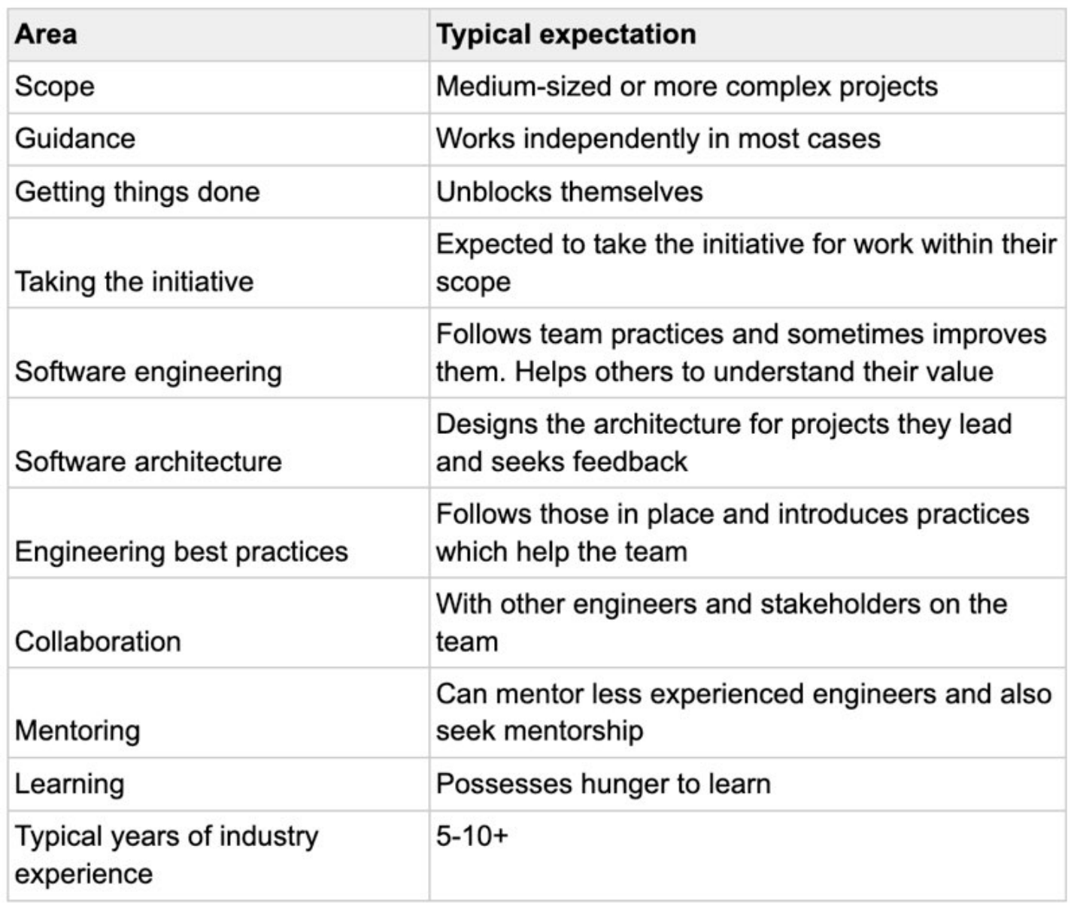
- Senior as a terminal level
  - At some companies, the senior engineer level is considered a “terminal level.” This means there is no expectation for engineers to progress further. It also signals that getting promoted to the next level is far rarer and much more challenging, than reaching the senior level is.
  - Senior engineers are expected to be autonomous and to solve complex projects and problems by themselves. Plenty of teams and projects require no more expertise.
- Getting things done: perception and reality [Note: in this part there are some nice explanations of how to communicate and how not to communicate]
  - Perception and reality may differ
  - Communicate what you do
  - Under-promise, over-deliver, over-communicate
  - Communicate roadblocks early and offer tradeoffs
- Your own work
  - Deal with inbound requests efficiently
    - Block out time for uninterrupted, deep work.
    - Say “not right now” when in the zone.
    - Timebox how long you spend helping with something.
    - Turn sync requests to async ones.
    - Redirect requests to a colleague who’d benefit.
    - Know your “#1 priority work” at all times.
    - Prioritize requests.
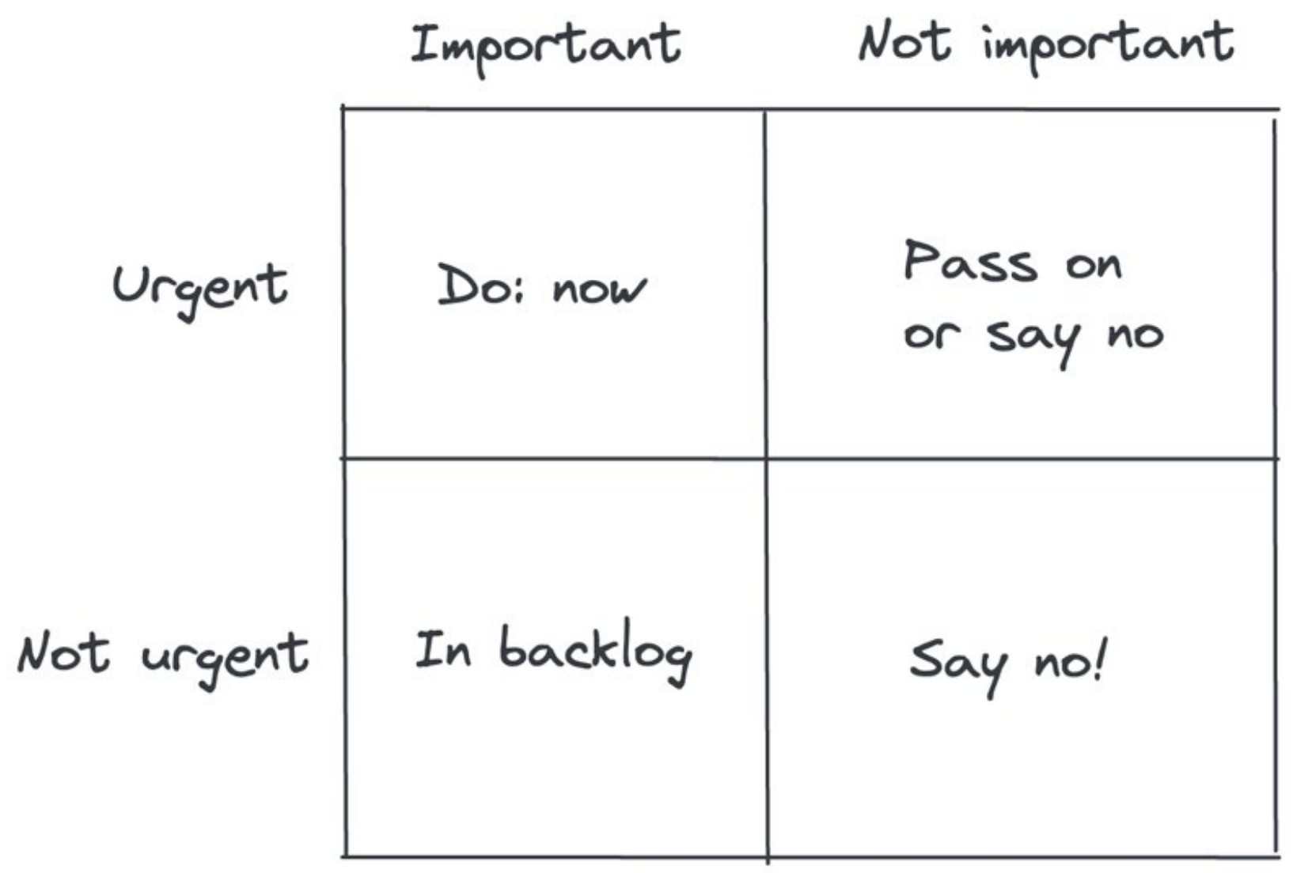
    - Create a system for capturing important but not urgent work.
    - For anything unimportant, say no.
    - Purge your to-do list, every now and then.
      - The reality is that what’s important to you changes over time. Any list you create of important work will eventually go stale.
    - Know that it’s normal to feel overwhelmed.
- When it’s done, it’s properly done
  - Approaches:
    - Have a written specification.
    - Have a testing plan.
    - Include testing, monitoring, and alerting as part of estimations.
    - Don’t “throw it over the fence” to QA.
  - Work in short iterations
    - Ship something every day
  - Long stretches of work.
    - Examples where are needed:
      - Research
      - Improving tooling or infrastructure
      - A major refactor
      - A rewrite
    - Long stretches of work mean less feedback
- Your Team
  - Break down and estimate projects
  - Document for others
  - Unblock your team
  - Become better at thinking “outside the box”
- The Big Picture
  - Become product-minded
  - Understand the business
- Code Reviews
  - Good code reviews
    - A good code review points out obvious improvements to make, such as hard-to-understand code, vague names, commented-out code, untested code, or overlooked edge cases. It also notes when too many changes are crammed into one review, suggests keeping code changes as single purpose, and breaking down the change into more focused parts.
    - Better code reviews are also empathetic. They recognize that the person who wrote the code spent a lot of time and effort on the change. These code reviews applaud nice solutions and are generally positive in tone.
  - The tone of the review
  - Requesting changes before approving
    - Good code reviews don’t approve changes while unresolved questions remain. However, they make clear which questions or comments are nonblocking or unimportant.
  - Talking to each other
    - When a conversation turns into a lengthy back and forth, reviewers reach out to the author in person, in order to not use up more time on the code review tool.
  - Nitpick comments
    - Excessive nitpicking can be frustrating and a distraction from more important topics.
    - Too many nitpicks are a sign of a lack of tooling, or standards.
  - New joiners and code reviews
    - Better code reviews pay attention to making new joiners’ first few reviews a great experience.
  - Cross-office, cross-timezone reviews
  - Resources:
    - Code review developer guide by Google
    - Code review guidelines by GitLab
- Pairing
  - Definitions:
    - Pair programming, when done in person, this usually involves sitting next to each other and working on the same screens, taking turns with the keyboard
    - Pairing up means sitting next to each other or whiteboarding when it’s in person.
  - Situations where pairing can be useful
    - Onboarding to a new team, codebase or system
    - Implementing a feature
    - Debugging a tricky bug
    - Planning and architecting
    - Confirming you’re doing things correctly
    - Understanding how something works
    - “Cheat” by observing and learning how another developer works
  - Approaches when you’re more experienced
    - Define the problem
    - Get a sense of the urgency
    - When there’s time pressure, solve first while explaining, then follow up
    - Aim to teach your pair partner something, not just give answers
    - Avoid immediately giving answers, even if you can
    - Give the other person enough space to talk and type
    - Try to learn something from your pair partner
    - Give compliments when due
    - It’s natural to go off-track sometimes
  - Approaches when you’re less experienced
    - Respect their time and be flexible if they have something urgent to finish
  - Pairing is an approach that seems underutilized and undervalued, especially in remote working contexts. I suggest you use pairing to help others around you by offering to help a developer who seems stuck and pairing with colleagues who could unblock you.
- Mentoring
  - Informal mentorship
    - Mentoring mostly isn’t formal. Mentoring happens naturally when developers work together and collaborate.
  - Formal mentorship
  - Kicking off mentoring: the introductory meeting
Come prepared with a list of topics to discuss at the kickoff, such as:
    - Background
    - “What’s in it for me?”
    - Topics to cover.
    - Cadence.
    - Communication between catch-ups.
    - Short-term wins.
    - Evaluating progress.
    - Challenges.
  - Don’t forget, if you’re asked to be a mentor, it’s always okay to say “no.”
  - When you’re the mentor
    - Be clear on expectations from the start.
    - Listen to what the mentee has to say.
    - Avoid serving up answers on a silver platter.
    - Discuss specific situations to dive deeper.
    - Leverage your network to help your mentee.
    - Let your mentee know you’re on their side.
    - Aim to learn something new from your mentee.
    - Help mentees come up with multiple solutions to problems.
    - Tailor your approach for technical vs non-technical topics.
  - When you’re the mentee
    - Set clear expectations at the start. Come prepared to catch up with your mentor and make good use of their time. Bring challenges, wins, and topics about which you’d like their input. Have a list of topics to discuss. As you get advice and ideas, commit to actions and follow them through. Let your mentor know how it goes.
    - It can be helpful to keep a running doc to share with your mentor. You can drop notes in it between catch-ups about topics to raise next time, such as: Key events, Reflections on action items / guidance / discussions, from last time, A current challenge, A recent success, mentor to share their opinion.
  - There’s no one pattern for mentorship. For most people, it’s a mix of informal knowledge sharing and regular catch-ups.
  - Every mentoring relationship is different; what’s important is that it works for both mentor and mentee.
- Giving Feedback
  - My take is that it’s a wasted opportunity to not give feedback, as long as it’s done respectfully and with the intent of helping the other person grow.
  - Better ways to give positive feedback
    - Make it concrete
    - Make it sincere
  - Giving constructive or negative feedback
    - Ask questions before jumping in with feedback.
    - Deliver corrective feedback empathetically.
      - “Radical Candor” by Kim Scott
      - “Crucial Conversations” by Joseph Grenny, Ron McMillan, Al Switzler and Kerry Patterson
- Working with other engineering teams
  - Often, the best pointer for whom to talk to is checking who changed a relevant line of code last time, and reaching out to them.
  - Draw a map of teams
    - Draw up a map of engineering teams connected to your team, and which ones your team has connections with.
  - Introduce yourself to other teams
The goal of an introductory meeting is two-fold:
    - Gather information about a team that can speed up your work, later
    - Build a personal connection
- Influencing Others
  - Ship great work
    - What “great” looks like depends on your environment
  - Get to know other people
    - Try to make time to break out of your engineering bubble. Talk with product people, colleagues in design, data science, other non-engineering functions, and on the business side.
    - Join calls with engineers on other teams whom you work with.
    - There are several benefits of talking with people, as opposed to just focusing on the work.
      - First, you’ll each get a feel for who’s behind those emails and pull requests.
      - Second, you’ll gather a lot more context about how they work.
      - Finally, you might make an unexpected connection, via similar views, personal interests, or something else.
  - Take part in cross-functional projects
    - Get involved in RFCs / design docs / cross-team planning.
    - Take part in cross-team projects.
      - I’ve found that one of the best ways to network is by not “networking” at all. Instead, just work on a shared problem.
  - ‘Promote’ your work – without boasting

